Vol. 3 – No. 69 – Tonga April 30th, 2026 Baha’i’s of Tonga
. . . . . . . . . . . . . . . . . . . . . . . . . . . . . . . . . . . . . . . . . . . . . . . . . . . . . . . . . . . . . . . . . . . . . . . . . . . . . . . . . . . . . . . . . . . . . . . . . . . . . . . . . . . . . . . . . . . . . . . . . . . . . . . . . . . . . . . . . . . . . . . . . . . . . . . . . . . . . . . . . . . . . . . . . . . . . . . . . . . . . . . . . . . . . . . . . . . . . . . . . . . . . . . . . . . . . . . . . .
The Monthly Bugle

"Blessed are they who follow the Light in their youthful days..."
Editorial Board:
Youth Media team

. . . . . . . . . . . . . . . . . . . . . . . . . . . . . . . . . . . . . . . . . . . . . . . . . . . . . . . . . . . . . . . . . . . . . . . . . . . . . . . . . . . . . . . . . . . . . . . . . . . . . . . . . . . . . . . . . . . . . . . . . . . . . . . . . . . . . . . . . . . . . . . . . . . . . . . . . . . . . . . . . . . . . . . . . . . . . . . . . . . . . . . . . . . . . . . . . . . . . . . . . . . . . . . . . . . . . . . . . .

Have You Heard The Latest Good News?


Bambi
al.moeaki@gmail.com

Feasts & Holy Days Timeline

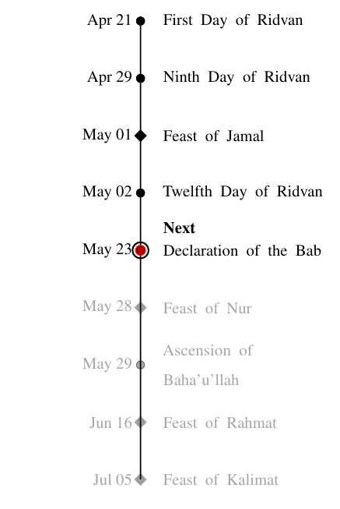

Figure 1: Upcoming Baha’i Feasts and Holy Days

idvan, the most sacred Baha’i fes- tival, commemorates the period
R
in 1863 when Baha’u’llah declared His mission as a Manifestation of God. Celebrated over 12 days, Baha’is around the world gather for prayer, re- flection, and community events with observances on the 1st, 9th, and 12th days. This festival also includes the election of Local and National Spiri- tual Assemblies, held in a spirit of joy, unity, and devotion.

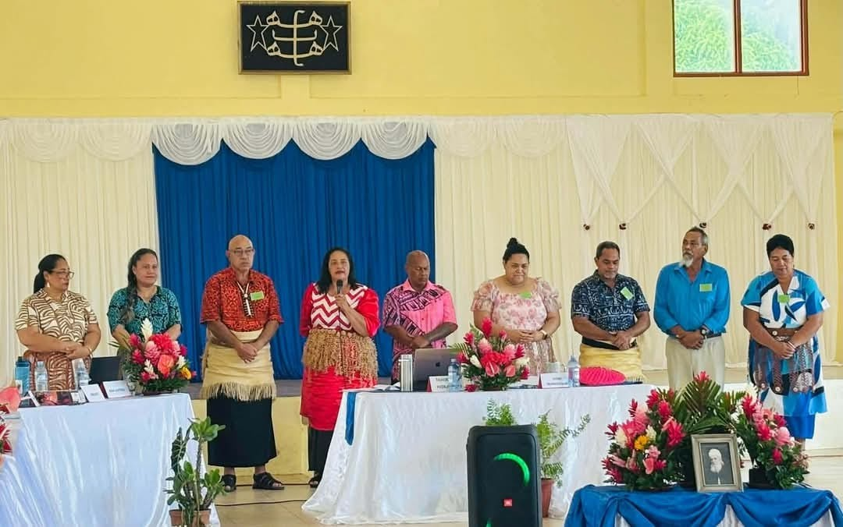
Unit Convention

Figure 2: Newly elected NSA members 2026

Over the course of 3 days, Baha’is
gathered to reflect on community affairs, reflect on messages and guidance from the Universal House of Justice (UHJ), and ultimately, appointing 9 new members of the National Spiritual Assembly (NSA) to serve over the next four (4) years. The members are:
- member 1
- Member 2
- Member 3
- Member 4
- Member 5
- Member 6
- Member 7
- Member 8
- Member 9

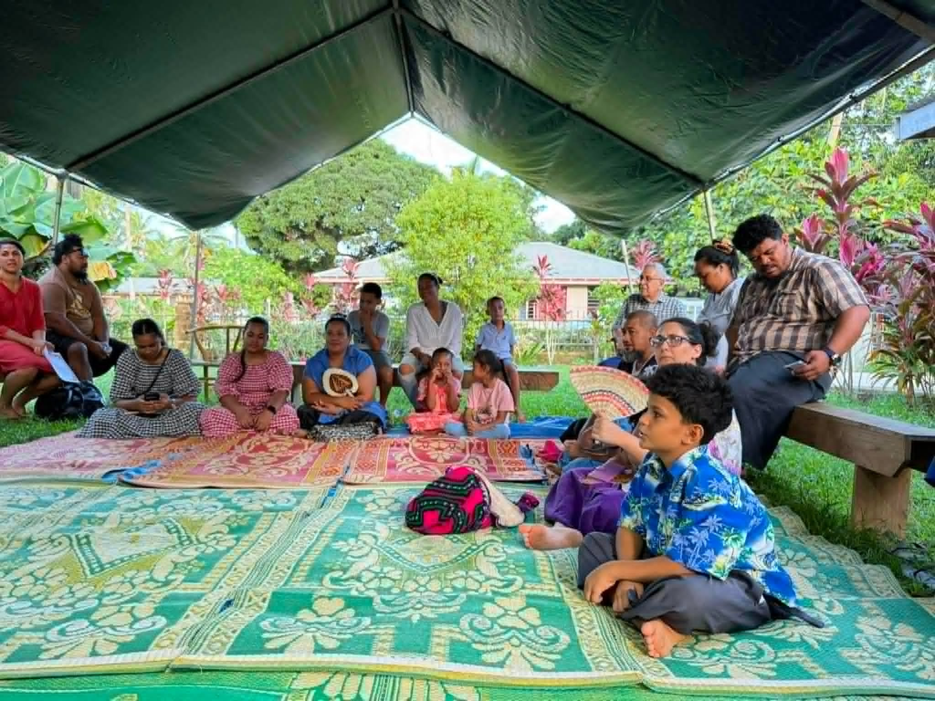
Feast of Jamal / Ridvan
Figure 3: Devotion at Tofoa Community

(Decription xy) – LSA list for Tofoa?

Gate to Glory and Greatness
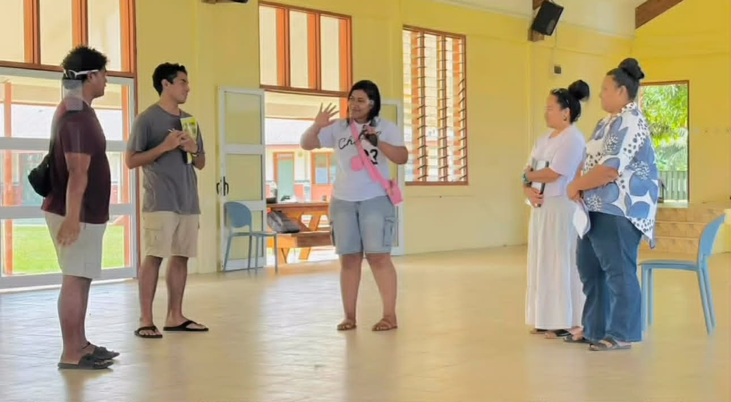
Figure 4: Sharing a Prayer

A nation-wide camp was conducted over 5 days, devoted to a focused study of Book 7 (’Walking a Path of Ser vice’) with the intention to strengthen the capacity of the friends in tutoring Book 1. Core principles nurtured the warmth of sharing prayers, of creating spaces that nurtured an advancement of understanding, and over all, a shift in perspective to contribute this spiritual solution as something that is not just for Baha’is, but for everyone. Following this camp, 20+ new tutors set out with renewed energy and enthusiasm, leading elevated conver sations within their families, schools, and within their institutions.

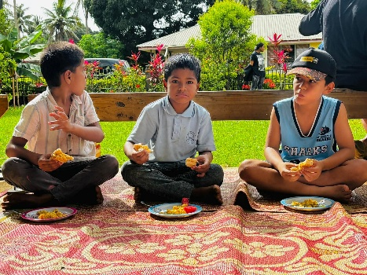
Saturday Devotions
Figure 5: Devotions, Zumba & Food

The friends gather for devotions at the Payman residence every Saturday at 7:45am. Prayers are chanted and songs are sung with beauty and reverence. Following the devotional portion, Zumba sessions are run in a spirit of enthusiasm and joy before breakfast is shared amongst friends. The engagement across a wide age range adds to the vibrancy and community connection within this weekly space.

Youth
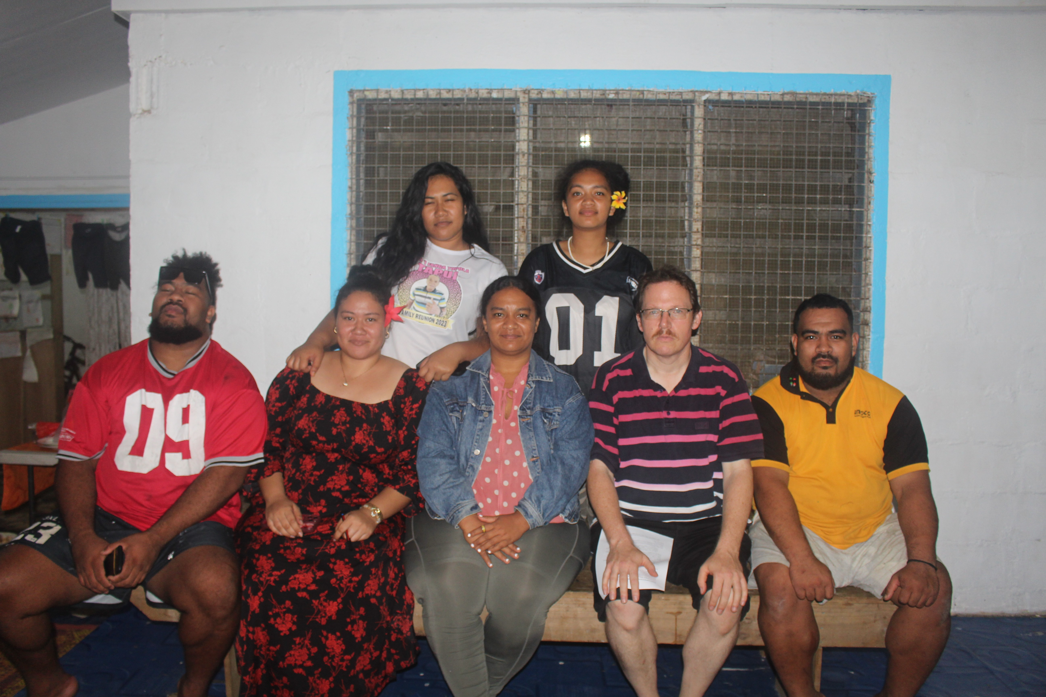
Dinner & Deepening
Figure 6: Post dinner & Deepening

The youth continue to engage in weekly deepenings, covering a wide range of spiritual topics, which include the purpose of trials, the sacred duty of voting, conversations exploring marriage, equality of men and women, the Seven Valleys- and many others. These are hosted at the Kafalava Jnr residence on Mondays at 7pm, with the aim to deepen the knowledge of the youth and to build capacity to share on the core principles of the Faith so relevant to everyday life.

Zumba at 6am
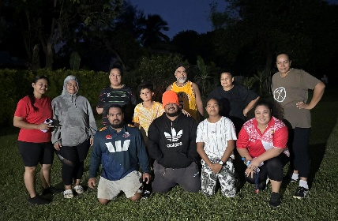

Figure 7: Morning exercise

As of April 4th, morning Zumba sessions will run every Monday and Wednesday from 6:00-6:30am - promoting healthy and active lifestyles within the community. These will take place at the Pongi residence – open to all friends and family to join for laughs and Zumba!

Youth night (Saturdays @ Mercy)
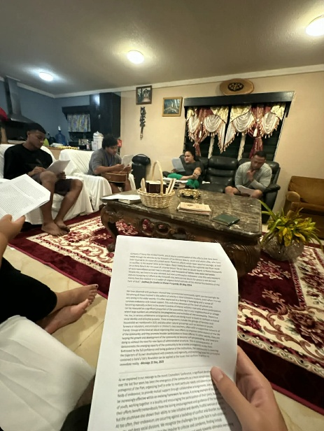

Figure 8: Youth deepening

Junior Youth

Figure 6: JY photo

(Description xy)

Childrens Class

Figure 7: Children Class photo

(Description xyz)

Upcoming Events:

- Book 8 study circle
- Declaration of the Bab

